Dissertation dev log
Week 14:
Current Goals for Full Dissertation session:
- Voronoi clipping implemented
- An implementation in GLSL, for performance comparison
- Research question made more precise and naturalistic
- Workplan make clearer
- Gather data
- Analyse data
- Specification for computing artefact that integrates societal, user, and business needs, demonstrating impact, usability and values to stakeholders
- Design rational, usage guidance, maintainability and architecture overview are provided
- Abstract
- Results and analysis section
- Discussions and conclusion
- Statistics addendum
- Artefact testing
- Critical addendum
Completed:
- A way to interact with the fragmented mesh
- A working Voronoi fracture in 2D for demonstration
- Working Voronoi fracture in 3D
- Comprehensive background done, covering triangulation, fracturing methods used in games, Graphics API’s, Performance of Graphics API’s, Point sampling, and Voronoi Clipping.
- Clearly stated research question
- Clear, feasible hypothesis, that is well scoped.
- An introduction that provides clear context for the project, and explains the need for the research, including positive impacts and who benefits. It should also highlight the motivation for the project.
- Professional, ethical, sustainable, legal, and social review carried out.
- A plan for security and privacy concerns has been written, and data is well managed.
- A methodology for how the project is going to be researched, and how its going to be evaluated
- A working way of profiling the results of the prototype
- A Critical Review of current technology is completed, that highlights where the gap in research is, and the how this project fills it.
- Project is ethically robust
- Project plan with gantt chard
- Profiling results that are easily replicated and are well documented.
- Fracture implemented in both OpenGL and Vulkan
- Readme that highlights development roadmap
Bugs
- When clipped, the mesh of the light pole is gone. The rest works fine, and this occurs no matter the number of cells.
- With plane clipping, when using 1000 points, some of the cells seem to randomly grow then shrink in size, could be due to the rendering engine, rather than Voronoi
Development notes:
The cells have been clipped to a mesh, as shown in figure 1, but the cells have not been properly clipped to the mesh, resulting in the mesh appearing hollow. Island separation has been done, separating meshes that are in the same cell, but are now disconnected. A problem faced was how to clip the cell to the mesh, so it was no longer hollow. The solution I have thought of to this, is to run the Plane cutting algorithm on the triangle’s planes, to only get the inside parts of the cell. This meant I had to fix plane cutting, which was done by ordering the intersecting faces after getting each intersecting point.
Images:
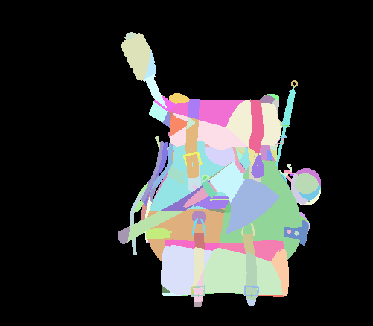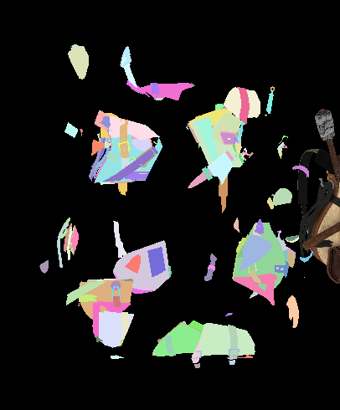

References:

